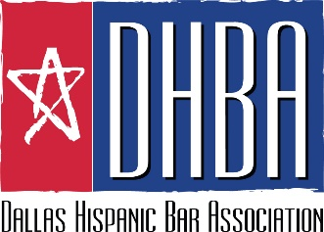

SPONSOR CONFIRMATION FORM
Noche de Luz ⏐ Saturday, October 28, 2017
Perot Museum of Nature and Science, 2201 N. Field Street, Dallas, Texas 75201

Company/Firm: _________________________________________________________________________________________________

Contact Name: _________________________________________________________________________________________________

Address: _________________________________________________________________________________________________

Telephone: _________________________ Email Address: ___________________________________________________

Sponsor Level:
_____ Platinum ($10,000) _____ Medium Firm ($1000) _____ Public Official ($250)
_____ Gold ($5,000) _____ Small Firm ($500) _____ Past President ($250)
_____ Silver ($2,500) _____ Familia ($500)
_____ Amigo/a ($250)

Individual Tickets:
_____ (On/Before October 12: $125 DHBA members/$150 non-members)
(After October 12: $150 DHBA members/$175 non-members)

Payment Options:
_____ I am enclosing a check in the amount of $ ____________ made payable to the Dallas Hispanic Bar Association.
____ I am mailing/emailing/faxing my Sponsor Confirmation Form today and I agree to remit payment in the amount
of $ _______________ no later than _______________.

Please send the Sponsor Confirmation Form and payment to the following:
Teresa Guerra Snelson
DHBA Annual Event
Fishman Jackson Ronquillo, PLLC
700 Three Galleria Tower
13155 Noel Road, L.B. 13 Dallas, TX 75240

Phone: 972-419-5500
Fax: 972-419-5501
E-mail: tguerrasnelson@fjrpllc.com

By October 12, 2017, please forward a high resolution (JPEG) copy of your company logo with subject line DHBA Noche de Luz Logo to: DHBA@DallasHispanicBar.com

You will not receive physical tickets for the Annual Event. Instead, your guests will be on a guest list. To ensure that your guests are on the guest list, please e-mail or fax a list of your guest names to tguerrasnelson@fjrpllc.com no later than October 18, 2017.

*** To be included in our event materials, we must receive your Sponsor Confirmation Form no later than October 12, 2017***

